DS 620 Machine Learning and Deep Learning
HOS06Aa: Artificial Neural Networks using TensorFlow
03/11/2024 Updated by Sherin Aly
05/02/2024 Reviewed by Naveena Moddu
08/21/2025 Reviewed by Ashwin Paturi
10/28/2025 Reviewed by Kina Anh Bui

School of Technology & Computing (STC) @ City University of Seattle (CityU)

Before You Start
- The directory path shown in screenshots may be different from yours.
- The document uses Google Colaboratory as the default compiler. If you want to run the code on a local machine, you need to configure the environment.
- Some steps are not explained in the tutorial. If you are not sure what to do:
  - Consult the resources listed below.
  - If you cannot solve the problem after a few tries, ask a TA for help.

Learning objectives
- Understand Artificial Neural Networks
- Build a Neural Network with Keras

Resources
- 3Blue1Brown. (2017, October 5). But what is a neural network? | Chapter 1, Deep learning [Video]. YouTube. https://www.youtube.com/watch?v=aircAruvnKk
- fchollet. (2020, April 12). Keras documentation: The sequential model. Keras. https://keras.io/guides/sequential_model/
- Géron, A. (2019). Hands-on machine learning with scikit-learn, keras, and tensorflow (2nd ed.). O’Reilly Media.
- Ognjanovski, G. (2019, January 14). Everything you need to know about neural networks and backpropagation — Machine learning easy and fun. Towards Data Science. https://towardsdatascience.com/everything-you-need-to-know-about-neural-networks-and-backpropagation-machine-learning-made-easy-e5285bc2be3a

Introduction
Taking inspiration from the structure of the human brain, the Artificial Neural Network (ANN) is the core of deep learning. ANNs are versatile, powerful, and scalable, making them ideal for tackling large and complex Machine Learning tasks. In this week’s HOS, we will introduce the Keras API, a powerful, high-level API that allows us to build, train, and evaluate neural networks.

Neural Network
The neural network consists of three layers: an input layer, a hidden layer, and an output layer.
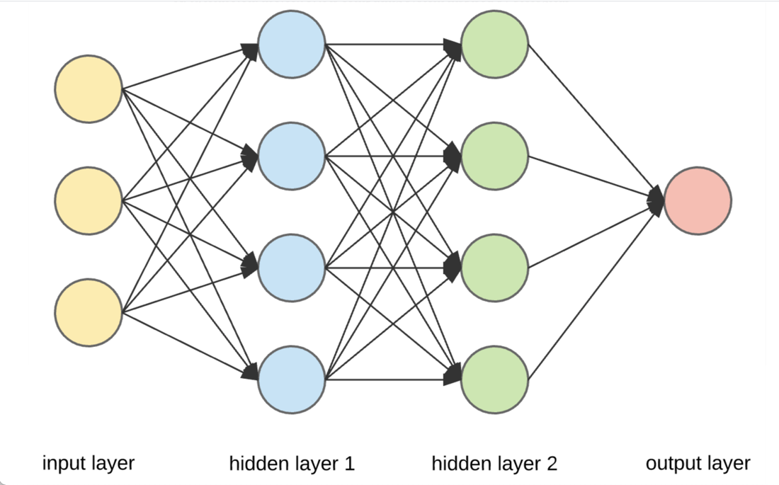
Figure 1: Neural Network Architecture (Ognjanovski, 2019)
- Input layer: where data is fed into the network to initialize it.
- Hidden layers: one or more layers in between the input and output layers where all computation is done. The number of hidden layers is arbitrary, depending on the user.
- Output layer: the layer that produces results based on the input and computation performed in the hidden layers.

Each layer contains nodes (the circles in Figure 1), and each node is connected to every node from the previous layers - this is how data travels through the neural network. Like other Machine Learning models, a Neural Network takes in training data, learns its underlying pattern, then uses those patterns to predict future data. In this HOS, we will use the MNIST handwritten digit dataset and build a neural network to classify handwritten digits.

Import Libraries
- Go to https://colab.research.google.com. Create a new notebook and name it “ANN.ipynb”.
- Now, we need to import the necessary libraries. Type the following in your code cell, then click the play button or Ctrl + Enter to run the cell.

Obtain data
- Again, we can skip straight to loading the data, as we will be using a dataset provided by Keras. Click the + Code button to add a new code cell. Type the following code in the cell, then click the play button or Ctrl + Enter to run the cell.

- Let’s start by exploring the shape of the data. Click the + Code button to add a new code cell. Type the following code in the cell, then click the play button or Ctrl + Enter to run the cell.

- We can also examine an individual sample to understand the input properties. Click the + Code button to add a new code cell. Type the following code in the cell, then click the play button or Ctrl + Enter to run the cell.

Note: You can click “show data”

The image is represented as a 28x28 matrix, with each cell corresponding to a pixel. The value of the cell indicates the grayscale value of each pixel.

- Let’s visualize an image. Click the + Code button to add new code cells. Please type the following code in the cells, then click the play button or Ctrl + Enter to run them.

- Since Gradient Descent will be used to train the network, we need to normalize the input feature. The maximum value of a cell is 255, so we will divide all the input values by 255. Validation data is also required during the training process so that we will split the input data into a validation and training set. Click the + Code button to add a new code cell. Type the following code in the cell, then click the play button or Ctrl + Enter to run the cell.

Reshape and convert the data to be ready for the NN
Steps 8 and 9 are optional in this example. You will notice that you encountered no issues without performing those steps. However, it's important to note that in most cases, these steps are essential for proper data handling and model training, especially when working with neural networks.

- Reshaping the Data: Neural networks typically expect input data in specific shapes. In the Keras Sequential model case, the first layer expects the input shape to be specified. In this case, we're using a flattened layer as the first layer, which expects input data in the shape of (batch_size, 28, 28, 1), where batch_size is the number of samples in each batch. The -1 in the reshape function means that NumPy will automatically determine the size of that dimension based on the other dimensions and the total number of elements. Reshaping ensures the data is in the correct format for the model to process.

- One-Hot Encoding: The labels in the MNIST dataset are single digits from 0 to 9. However, in neural network classification problems, it's common to represent labels in a one-hot encoded format. One-hot encoding is a way of representing categorical data where each label is converted into a binary vector of length equal to the number of classes, and only one element in the vector is 1, indicating the class of the sample, while all other elements are 0. This is important because it provides a consistent representation of the output layer of the neural network, making it easier to interpret and compare predictions with the ground truth labels. It also helps avoid any ordinal relationship between classes that the network might infer if the labels were represented as integers.

Create an Artificial Neural Network with 2 Hidden Layers
We will create a neural network by initializing a Sequential model in this example. The Sequential model is the simplest kind of Keras model to use for neural networks. It is appropriate for a plain stack of layers where each layer has exactly one input tensor and one output tensor. Next, we will add a flattened layer, which is a class of reshaping layers. Its role is to convert each input image into a 1D array. Since it’s the first layer in this example, it also acts as an input layer. The final type of layer is the dense layer, a class of core layers. Its role is to carry out computation using an activation function.

- Click the + Code button to add new code cells. Please type the following code in the cells, then click the play button or Ctrl + Enter to run them.

Compile and train the model.
Once the model is created, you need to use the compile method to specify the optimizer and loss function that it will use.

- Click the + Code button to add a new code cell. Type the following code in the cell, then click the play button or Ctrl + Enter to run the cell.

- Finally, we will train the model by passing the training data and validation data into it using the fit method. The epoch parameter is the number of cycles the training data is passed through in the network. Click the + Code button to add a new code cell. Type the following code in the cell, then click the play button or Ctrl + Enter to run the cell.

Evaluating testing data
- The Keras model comes with an evaluation method for testing data. Click the + Code button to add a new code cell. Type the following code in the cell, then click the play button or Ctrl + Enter to run the cell.

Push your work to GitHub
Click File → Download → Download .ipynb.
The file will be downloaded to your Download folder (or another folder according to your browser settings).
Move the downloaded ipynb file to your Module06 folder.
Follow the instructions on the CityU STC TA Center Github.io. Submit your work page.

